The International AIDS Society

Educational Fund meeting: Outcome report
28-29 November 2018
Port-au-Prince, Haiti

Retention in Care – PrEP – Tuberculosis
Science and Community in the HIV Response
in the Caribbean

Table of Contents

Acknowledgements iii
1. Introduction 1
2. Background and context 2
3. Meeting report 4
4. Conclusion 20
Appendix 1 - Programme 23

List of abbreviations and acronyms

AIDS Acquired immune deficiency syndrome
ART Antiretroviral therapy
CDC Centers for Disease Control and Prevention
CSO Civil society organization
DR Dominican Republic
DST Drug susceptibility testing
DTG Dolutegravir
FTC Emtricitabine
GHESKIO Groupe Haïtien d'Études du Sarcome de Kaposi et des infections opportunistes
GNP+ Global Network of People Living with HIV
HCV Hepatitis C Virus
HIV Human immunodeficiency virus
HTS HIV testing services
IAS International AIDS Society
IAS 2018 10th IAS Conference on HIV Science
INCMNSZ National Institute of Medical Sciences and Nutrition
KP Key population
LTFU Loss to follow-up
MDR-TB Multidrug resistant tuberculosis
MSM Men who have sex with men
MSPP Ministère de la Santé Publique et de la population
NCD Non-communicable disease
NGO Non-governmental organizations
PAHO Pan American Health Organization
PANCAP PAN Caribbean Partnership Against HIV and AIDS.
PEP Post-exposure prophylaxis
PEPFAR President’s Emergency Plan for AIDS Relief
PLHIV People living with HIV
PrEP Pre-exposure prophylaxis
RCT Randomized controlled trials
TDF Tenofovir disoproxil fumarate
TGM Transgender men
TGW Transgender women
UHC Universal health coverage
UNAIDS Joint United Nations Programme on HIV and AIDS
USA United States of America
YPLHIV Young people living with HIV
ZL/PIH Zanmi Lasente/Partners in Health

Acknowledgements
The International AIDS Society (IAS), alongside their collaborators Les Centres GHESKIO and the Haitian Programme National de Lutte Contre les IST / VIH / SIDA (PNLS), would like to acknowledge and thank all participants, stakeholders and service providers in the Caribbean region for their contribution towards making the IAS Educational Fund meeting of November 2018 at the Karibe Convention Center in Port-au-Prince, Haiti, the huge success that it was. It would also like to recognize the commitment and participation of international, regional, national and local HIV scientists and researchers, policy makers, implementers, community representatives and relevant stakeholders who came together to draft meaningful change on the particular topics of retention in care, PrEP and Tuberculosis in an effort to push forward the fight against HIV / AIDS for the inhabitants of their region.
Special acknowledgements are extended to the organizers of Science and Community in the HIV Response in the Caribbean 2018 Post-Conference Workshop for their collaboration in the planning of this important event. In particular, thanks go to the organizing committees of:
- IAS: Dr Russell Pierre, Dr Celia Christie Samuels, Dr Luis Enrique Soto-Ramirez, Erika Lundström, Laure Felix-Bower, Lauranne Botti and Jade Robert
- Les Centres GHESKIO: Dr Jean William Pape, Dr Marie Marcelle H. Deschamps, Dr Bernard Liautaud, Mrs Claudia Thomas Riché, Mrs Anaëlle Canez, Dr Jean Edouard Mathon and Dr Vanessa Rouzier
- PNLS: Dr Kesner Francois, Dr Joelle Daes
The IAS would also like to extend its appreciation to ViiV Healthcare for their financial support for the meeting.
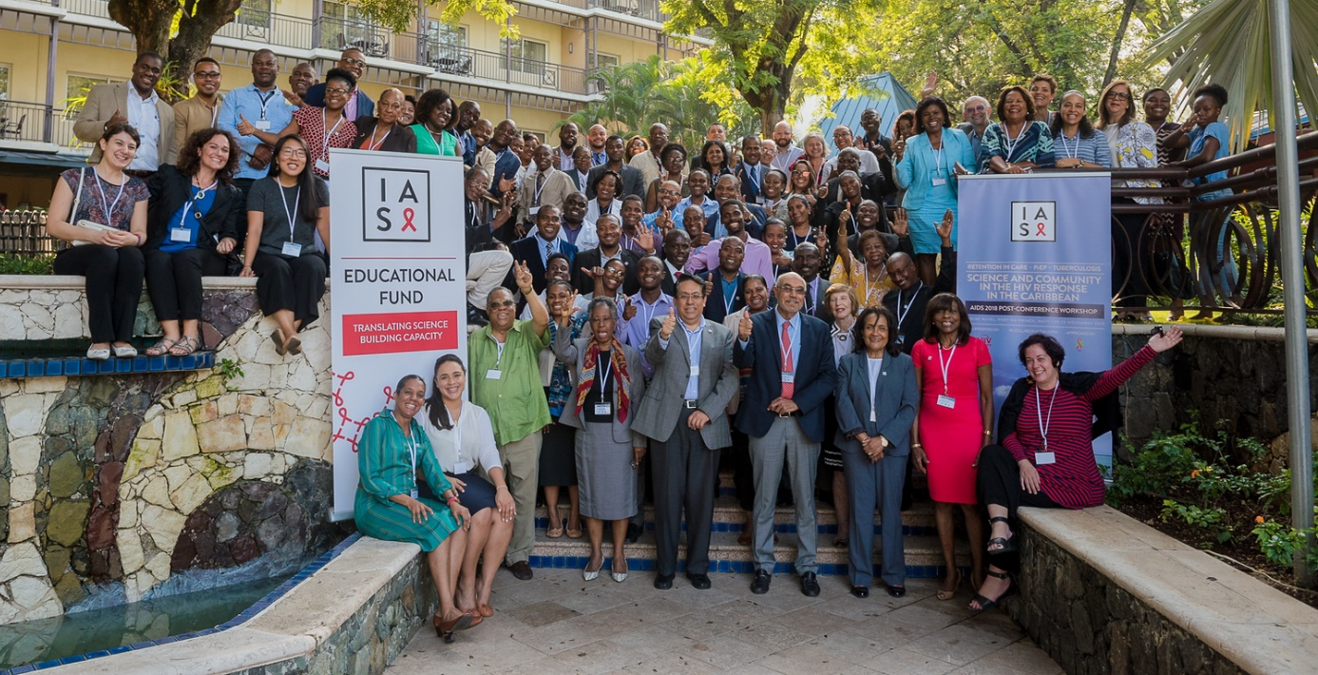
Les Centres GHESKIO would also make a special mention to Caribbean Flavors and Fragrances for sending Caribbean guests off with a reminder of Haiti through their Vetiver oil.

Introduction

The International AIDS Society (IAS), in collaboration with Les Centres GHESKIO, fully endorsed by the Programme National de Lutte contre le Sida (PNLS, Haitian Ministry of Health and population), have had the great opportunity to organize an AIDS 2018 post-conference workshop on the theme of Retention in Care – PrEP – Tuberculosis, Science and Community in the HIV response in the Caribbean. The workshop was held on 28-29 November 2018 at the Karibe Hotel, in Port-au-Prince, Haiti.
The workshop was part of regional meetings organized through the IAS Educational Fund to address the gap between HIV science and implementation. While the HIV response has made considerable progress, this gap remains a persistent challenge for effectively responding to the epidemic globally.

The IAS Educational Fund was created with the aim of making scientific forums more accessible to IAS members and their communities. In addition to providing direct support to clinicians and other health professionals to attend global conferences, the IAS Educational Fund, through regional meetings, enables HIV health professionals, advocates and policy makers to participate in regional meetings to access the latest scientific breakthroughs and evaluate the impact of this information on the epidemic at a local level.

Les Centres GHESKIO, based in Port-au-Prince, Haiti, was the first institution in the world exclusively dedicated to the fight against HIV/AIDS. A French acronym meaning the Haitian Group for the Study of Kaposi’s Sarcoma and Infectious Diseases, GHESKIO was founded in 1982 by a consortium of Haitian health professionals investigating a disease later identified as AIDS. It is a Haitian, autonomous and a not-for-profit institution of excellence whose mission for the years 2018-2022 aligns with that of the Ministry of Public Health and Population (MSPP), because Haiti faces two major public health issues: infectious diseases and chronic non-communicable diseases. The ultimate goal of GHESKIO is to develop integrated models of prevention and care and to expand them, in collaboration with MSPP, nationally. GHESKIO is presently the largest provider of HIV/AIDS and tuberculosis (TB) services in the Caribbean. Together with other partners, GHESKIO contributes to the reduction of morbidity and mortality through research, training and services by targeting endemic diseases of major importance and reproductive health. For more than 35 years, the story of HIV/AIDS in Haiti has been inseparable from that of GHESKIO.
The workshop was co-chaired by Dr. Luis Soto-Ramirez (Mexico), Dr Jean William Pape and Dr Marie Marcelle H. Deschamps (Haiti) and Dr Mónica Thormann (Dominican Republic).

During the workshop, key scientific and policy content from the 22nd International AIDS Conference (AIDS 2018) in Amsterdam was shared and discussed, as well as implementation science priorities. Specific selected topics included retention in antiretroviral therapy (ART), pre-exposure prophylaxis (PrEP) implementation and co-morbidities (TB/ MDR-TB). Scientific research results on these specific topics were discussed for policy and programme improvements in the Caribbean region.

Background and context

Although Caribbean islands, countries and territories are part of the Americas, they clearly share common ethnic, politic and cultural history that are re-enforced by permanent migration of populations. This largely justifies exchanges on public health concerns between the 33 countries and territories despite diversity of languages (Spanish, English, French, Dutch, Creole, and more), political status and index of human development rank (from 58 to 168).

The Caribbean has the second highest HIV prevalence after sub-Saharan Africa and HIV incidence is still high amongst key populations (up to 25% amongst MSM).
It is estimated (PANCAP) that in 2017, 310,000 people living with HIV (PLHIV) live in the Caribbean. New infections in the Caribbean went down from 19,000 in 2010 to 15,000 and AIDS-related deaths from 13,000 to 10,000. Despite this moderate progress, the impact of ART treatment on prevention of transmission is lower than expected. Progress towards the 90-90-90 targets is still slow: 73% of PLHIV in the region are aware of their HIV status and 57% receive ARV. If 70% of PLHIV on treatment are undetectable, only 40% of the total population is virally suppressed.
The majority of tuberculosis (TB) cases in 2017 were reported in Hispaniola (Haiti and Dominican Republic) and ongoing migration make TB a major concern for all the Caribbean region. Rates of MDRTB is also a high concern. Recent development in shorter treatments and in diagnostic tools (X-pert) should facilitate the epidemic control, but implementation delays could slow down the impact of these innovations.
Pre-Exposure Prophylaxis (PrEP) have now demonstrated over 86% efficacy in many trials. Globally 300,000 people are on PrEP in about 68 countries, but 71% of users are in North America. Although many Caribbean countries have manifested interest in this preventive intervention, only two have started implementing PrEP, mainly for highly exposed groups. The implementation of PrEP is still controversial, partly due to the stigmatization of MSM and partly due to the wide range of legal, economic, social, technologic, and logistical considerations linked to the implementation. Time has, however, come for more involvement towards implementing PrEP in the Caribbean.
Stigmatization remains a concern in the Caribbean, particularly for young people amongst key populations (KPs) such as MSM, transgender people and commercial sex workers. Access to screening tests and care remain limited for KPs and high stigmatization does not facilitate their life. Prevalence of HIV amongst MSM reaches 25% in some places. Major improvements to lifestyles of KPs are expected.
HIV financial commitment from the Global Fund to Fight AIDS, Tuberculosis and Malaria (the Global Fund) and the President’s Emergency Plan for AIDS Relief (PEPFAR) has been sustained and substantial in the region. The vast majority of regional funding has come from international donors’ agencies. Amongst 16 countries, 11 rely heavily on external funding and there are concerns about maintaining the same level of help in the coming years. More input from local governments are expected.
In April 2018, the IAS Educational Fund programme held regional meetings in Mexico on the theme, Translating Science to End HIV in Latin America and the Caribbean. Key issues discussed included HIV prevention, policy implementation for PrEP and PEP, ways to integrate HIV into national global health systems in Latin America and the Caribbean, barriers and opportunities faced by youth and service delivery to transgender populations and sex workers in the region. Representation from the Caribbean region was low, however, and the need to target the Caribbean region was identified, including providing an avenue for HIV professionals to discuss the translation of the latest science and implications for implementation locally. It is in this context and following the 22nd International AIDS Conference (AIDS 2018) held in Amsterdam that the IAS organized in collaboration with Les Centres GHESKIO the two-day AIDS 2018 post-conference workshop targeting the Caribbean region.
The workshop organizers selected three key themes of major interest for the Caribbean health care personnel and PLHIV: Retention in Care, PrEP and Tuberculosis.

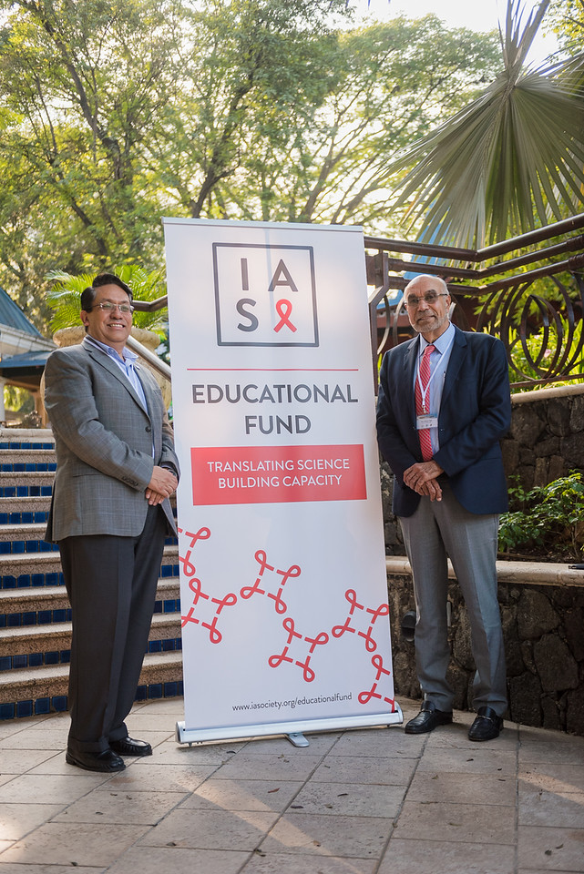

Meeting report

  - Executive summary
The IAS Educational Fund meeting in Haiti was held on 28 and 29 November with the theme, Retention in Care – PrEP – Tuberculosis, Science and Community in the HIV response in the Caribbean. More than 80 professionals in the HIV response in the Caribbean region, including clinicians, researchers, policy makers and community representatives, were present.

On the first day, key messages from AIDS 2018 were presented and discussed with the participants. Leading experts and IAS Members presented regional data regarding the status of the epidemic in the Caribbean region. This was followed by a panel discussion on the implementation of PrEP. On the second day, participants engaged in further discussions through two panel discussions. The first panel focused on retention in care while the second panel focused on TB and MDR-TB. This was followed by interactive group work, where participants provided recommendations on how to effectively translate the latest science presented into local policy and practice in the Caribbean region.

On the first day, Dr Lauré Adrien (Ministry of Public Health and Population (MSPP)) during his opening remarks, stressed the persistence of stigma and its impact on retention in Haiti and the multifaceted decisions needed to improve adherence and retention in care. Dr Adrien recognized the positive impact of the LINKAGES programme implemented in Haiti and progress initiated in prevention and care offered to MSM. He highlighted that new strategies such as PrEP must be developed for HIV screening and care to vulnerable groups. He also stressed that Tuberculosis and antibiotic resistance is of great concern. Dr Adrien emphasized the importance of the presence of HIV professionals and colleagues from all the Caribbean region.

  - Key messages from AIDS 2018
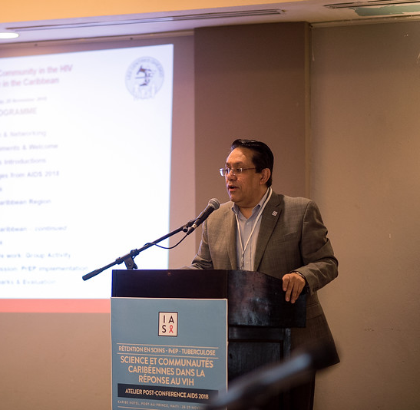
Dr. Soto-Ramirez (INCMSNZ, Mexico, and IAS Regional Representative for Latin America and the Caribbean) presented key messages from the AIDS 2018 Conference held in Amsterdam in July 2018.

Treatment: Updates on Dolutegravir (DTG)

Two small RCT studies demonstrated power but also limitation of Dolutegravir (DTG) monotherapy strategy compared to triple therapy (Early Simplified Trial, Zurich, monocentric; MONCAY, France, multicentric). Monotherapy should not be offered as an option for maintenance in suppressed patients because of risks of viral failure. GEMINI-1 and 2 Phase III trials demonstrated that dual therapy with DTG + 3TC is non-inferior to triple therapy including TDF, had fewer drug-related AEs with DTG + 3TC and change in renal and bone biomarkers were significantly favorable. However, dual therapy had less outstanding results in patients with less than 200 CD4 cells/mL. Safety and low toxicity of DTG was demonstrated. Dr Soto-Ramirez asked if we had to go back to Dual therapy with some risk of disrupting the new motto of test and treat strategy: U=U (undetectable means untransmittable).

Concern about use of DTG in pregnant women have been brought up by the Tsepamo Study that showed that using this ARV drug at the time of conception in Botswana increased incidence of NTD. Dr Soto-Ramirez recalled Mofenson’s presentation that available data on newer ARV (INSTIs, ETR and TAF) are insufficient to exclude even a twofold increase in overall birth defects or rare events such as NTD. Results updated on July 15, 2018 were presented. Next formal analyses from the Tsepamo study are expected for March 31, 2019, and will be presented during the 10th IAS Conference on HIV Science in Mexico in July 2019.

At present, WHO does not recommend DTG for women of childbearing age that are not using efficient contraception, and DTG is not presently recommended in children less than 6 years old or weighing less than 30 kg. Dr Soto-Ramirez insisted on the importance of in leaving decisions to pregnant women after full information about risks and benefits; most prefer to receive DTG when well informed about the risks. Dr Soto-Ramirez also reminded the participants about the current situation: 60% of HIV positive women are less than 26 years old and 50% of HIV positive pregnant women did not want to get pregnant.

It is remarkable that INH preventive therapy that has been promoted in PEPFAR countries still carry low/ poor rates of completion among HIV+ patients. For example, only half to one third of HIV positive patients in the DRC completed INH prophylaxis with no relation to age or gender. Even in Haiti, where efficacy of the intervention was first demonstrated, only 9% of HIV positive patients have completed this prophylaxis.

WHO is trying to offer more drugs and shorter treatment, even for MDR-TB, which will facilitate the management of patients.

A presentation (Kathrin Zürcher et al.) showed that in high burden countries there is an apparent risk of 10.6% of overtreatment because of discordant results. When susceptibility tests were concordant (80%), treatment was adequate in 96.8% of cases versus only 77.7% of patients with discordant results. Mortality raised from 6% in pan-susceptible patients who received adequate treatment to 53.3% in patients with any resistance who received inadequate treatment. Although the study included a limited number of patients (634), questions arose on the necessity of having susceptibility testing based on cultures in order to improve survival of MDR-TB patients.
The INSPIRING study (Dooley et al.) showed safety and efficacy of DTG-based ARV regimen including double dose of DTG (as long as RIF is used) associated to TB medications in patients with TB (most with pulmonary TB). Compared with an Efavirenz-based ARV regimen there was a non-inferiority of DTG after 48 weeks. No participant in either arm permanently discontinued treatment because of IRIS. Although it was expected that DTG may be related to more IRIS response because of its known rapid increase effect on CD4 count, it did not happen. In fact, there was even more TB-associated IRIS in EFV arm (9%) than in DTG arm (6%).

Retention in care

Retention in care: 90:90:90 objectives of Cascade goals is met only in “wealthier” European countries, with undetectable Viral Load (VL), and reached in only 26% of PLHIV in Eastern European countries (Teymur N, IAC 2018, Abs. MOAS3502).
A study on reasons for losing patients on follow-up in Kenya (Geng E, et al, Clinical Infect Dis 2016; 62: 935-944) found that among 68% who were found alive reported the following reasons: Transportation problems (33%-57%), work or child care (24%), feeling healthy (22%) or family obligations (21%).
MaxART (Abstract 13370, WEAX0102LB) was a stepped-wedge randomized-controlled health systems trial conducted in Swaziland: the intervention was offering ART regardless of CD4 count + clinical mentoring and community mobilization support. 3405 patients were enrolled across 14 clinics (40% during the intervention). 86% retention was observed under the intervention (universal test and treat) compared with 80% under standard of care at 12 months, a significant difference.

A study (C. Beauharnais, http://programme.aids2018.org/Abstract/841) on Retention rate among Haitian pregnant women under Option B + and factors of the loss to follow-up was done in 7 health institutions in Haiti and showed that 50% of women in the cohort had a single visit and did not return to the clinic. Denial, fear of stigma and disparity in care-giving was the most common factors found to be associated to loss to follow-up.
Retention in care (programme.aids2018.org/Abstract/841, 5206, 6675, 8354) depends on many universal and specific factors: Gender-based violence (trans women), Gender inequality, disparities in care, self-discrimination, denial. Bridging the knowledge-skills gap (second 90 target) entails the need to train health care providers to retain patients in care. The utilization of the viral load as a clinical management tool (third 90 target): only 80% of PLHIV have at least 1 VL per year, but 60% to 75% had no viral load. The key barriers to retention in care are cost and lab infrastructure.

PrEP
A US study (Sullivan PS, et al. AIDS 2018. Abstract LBPEC063) showed that PrEP uptake rates and HIV diagnosis correlated in a population of 13 years of age or older from 2012 to 2016. For 38 jurisdictions, with available viral suppression data, significant association between PrEP uptake and decrease in HIV diagnoses persisted after controlling for state viral suppression level.
ANRS Prevenir (Molina J-M, et al. AIDS 2018. Abstract WEAE0406LB) is an ongoing study on daily versus on-demand TDF/FTC oral PrEP conducted in HIV-negative adults at high risk of HIV infection with inconsistent condom use. On-demand PrEP strategy is not FDA approved. The study planned to enroll 3,000 participants and F-U of 3 years. Interim Analysis on data up to July 2, 2018 were presented: Participants (N = 1594) were predominantly MSM (98.8%) and white (85.2%); Mean follow-up: 7 months. Overall HIV infections averted: n = 85. High incidence of STI and new HCV infection (1.2/100 pt-year). No participant discontinued PrEP due to drug-related adverse events.
A Zimbabwe intervention (Makaita Gombe et al) tried to integrate PrEP in a public family planning facility and youth center to inform national roll-out in Zimbabwe. They started with training sessions: 2-week training on ART and 1-day training on PrEP; plus 1-day training on data collection. Uptake differed significantly between the rural and urban facilities: 9% in the rural Chimanimani site compared to 2.7% in the urban Harare site. Given the higher testing volumes at Spilhaus (Harare) and bigger staff complement, a higher PrEP uptake was expected compared to the rural youth center. In practice, the proportion of those testing HIV negative taking up PrEP was almost 4 times higher at Ngorima (9.0%) than at Spilhaus (2.7%). The majority of clients initiated on PrEP did not know their partner’s status or were in a new or known sero-discordant partnership. Potential reasons for this include differences in communities supported by both facilities: dispersed urban vs clustered rural, and endorsement of PrEP by traditional leaders.

  - HIV in the Caribbean region – Country profile summaries

Haiti:
Kesner Francois (PNLS) presented the main epidemiologic data on HIV in Haiti.

It is estimated that 150,000 people were living in the country in 2016. This represents 51.6% of the total number of PLHIV in the whole Caribbean area. The most recent survey (EMMUS VI report 2017) showed a national prevalence of HIV of 2% (2.4% urban vs 2% rural). This prevalence varies according to geographic areas, age and gender (2.3% Female / 1.6% Male). Prevalence is highest amongst MSM 12.9% and SW 8.7%, (CSW, IBBS, 2014).
The National Epidemiological Cascade: 79% PLHIV were diagnosed, 74% receive ART and 41% have suppressed viral load. Between 2010 and 2018, the number of patients on ARV went from 29,100 to 103,000 in 2018. Death among patients under ART stood at 4,700 in 2017.
Transition from Efavirenz-based first line of ART to DTG-based first line started in November 2018, promoting mainly single tablet TLD (Tenofovir/Lamivudine/Dolutegravir).
Main challenges highlighted include: Adherence and retention in care, stigmatization, coordination of interventions on TB and HIV epidemics, and funding (How to care for an increasing patient load, given decreases in budgets which are largely supported from multilateral aid).

Jamaica:
Dr. Geoffrey Barrow (University of the West Indies/Ministry of Health) presented the Jamaican HIV Response.
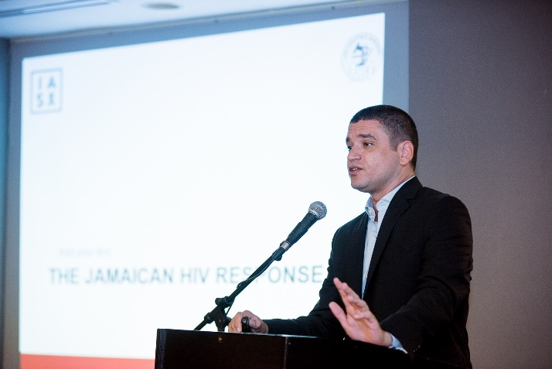
Estimation of number PLHIV: 33,700; 84% are diagnosed, 41% on ART, 52% of treated patients are virally suppressed (18 % of PLHIV are virally suppressed and are at a decreased capacity of transmitting the virus). Loss to follow-up at 1 year was 38% of patients entering in care and 15% for those on ART.
Number of new HIV infections in 2017: 1,197 (a reduction of 5.5% since 2013)
Number of HIV related deaths in 2017: 293 (an increase of 84.3% since 2013).

Estimated incidence of TB: 4.4 per 100,000 population (n =119) in 2017 (Source: NSU). Number of confirmed TB cases notified annually to the National Surveillance Unit in 2017 was less than 125. HIV co-infection was 18% of patients with confirmed TB.
PrEP is not yet implemented but 3 population groups have been identified for inclusion: MSM, preconception for sero-discordant couples and STI clinic attendees.

Barbados:
Dr. Nastassia Rambarran (EQUALS) summarized epidemiological data in Barbados.
PLHIV in 2016: 2,600. Prevalence among 5 to 49 year olds: 1.6%. MSM prevalence: 11.8%.
The Ministry of Health and Wellness has been using a Treat All approach since 2016. Care retention in 2013: 79% of those linked to care, 49% of PLHIV.
Free PrEP was started in March 2018 at the Ladymeade Reference Unit (LRU). Guidelines closely follow CDC and WHO recommendations. PrEP may be offered to any person in Barbados who is deemed to be at substantial risk for HIV.

PrEP is offered to anyone who:

- Is in an ongoing sexual relationship with an HIV-positive partner who is not virally suppressed
- Is a man who has sex with men (MSM) engaging in unprotected anal sex (receptive or insertive), is a transgender individual engaging in unprotected sex (vaginal or anal)
- Is involved in exchanging sex for money or goods and engages in unprotected sex (vaginal or anal)
- Is a MSM, or transgender person
- Is a person that exchanges sex for money or goods with diagnosed or reported STI
- Is having unprotected sex (vaginal or anal) with one or more partners of unknown HIV status who are known, or believed, to be at substantial risk of HIV infection
- Had received PEP for sexual exposure.

Thirty persons have been enrolled so far.

Dominican Republic:

Dr. Ellen Koenig (Instituto Dominicano de Estudios Virologicos (IDEV)) presented discussion points on HIV in the Dominican Republic (DR).
IDEV is currently following over 3,000 patients. Seroprevalence is 0.8% in DR. Test and Start are going into Third Year in Selected Clinics.
The Ministry of Public Health has estimated that the incidence rate could be 59.8 cases of tuberculosis per 100,000 inhabitants.

The government is conducting a feasibility study of PrEP, which began in 2017. At present time cost is estimated at about US $60/month which represents 25% of a worker’s salary. The flow of young MSM from Puerto Rico is attracted by this programme.

In the DR stocks of PrEP medications are a challenge to providing PrEP. The DR is also prioritizing psychological support for patients with poor adherence, by calling patients and visiting patients in their homes, in order to address the role that the economic situation, food insecurity, and education level play in adherence. The same factors also affect retention in care.

Mónica Thormann, MD, Consultant for the National TB and HIV Programs presented additional data on the Dominican Republic, National Response to HIV.
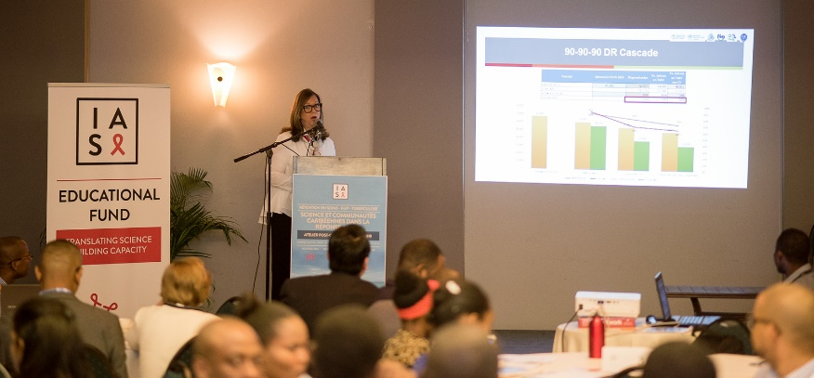

General prevalence of HIV is 0.8% (0.7% woman, 0.9% man). Sexual worker (FSW): 1.7% - 6.3%; Men that have sex with man (MSM): 3.9% - 6.9%; Migrants: 4.9% - 6.6%.

The total number of PLHIV is 56,176 (55,092 adults and 1,064 children). Among adults, 66.24% are actively under ARV, 67.62% for children. National Cascade of follow-up estimated that among the 67,286 adults HIV infected 90% are diagnosed, 70% are under ART and 64% are virally suppressed. In 2017, 4.4% of 1,700 pregnancies of mothers infected with the HIV virus had positive children. The same year, 4,093 cases of TB were diagnosed. The number of TB/HIV co-infected diagnosed patients was 892 (25% rate of co-infection with HIV). ART was delivered to 48% of co-infected patients).

Strengths of the TB / HIV Collaboration Dominican Republic: Progress has been made, such as a joint training, facilitated by a technical team of both programmes (about 400 professionals in 2018) and X-pert implementation (12 machines). A decision from the Ministry established that rapid test for HIV diagnostics can be performed by trained people other than medical technicians. This resolution was identified as a priority during the implementation of the Integrated Model for the two model programmes.
A Haiti –Dominican Republic Binational Meeting was held in Santo Domingo, October 31, 2018. During this meeting both countries recognized that tuberculosis control requires binational collaboration designed to provide a more effective response throughout the island, aimed at improving control of the epidemic that continues to cause unnecessary suffering and death in Haiti and the Dominican Republic. Among the specific objectives targeted to increase the success rate of Haitian TB patients under treatment to 90% on both sides of the border, and to reduce the rate of loss to follow-up in patients with TB to 5% per year. Dr Thormann also highlighted that about 10 million people live in the DR, and that there are one million migrants from Haiti and 250,000 from Venezuela in the country. By law all people living in DR should receive free public health services.
The DR also have many immigrants in the Caribbean islands and there is a need to create some tools to recommend patients to a place where they will be welcomed and well treated. For these reasons, Dr Thormann proposed to create a network in order to retain patients in care.

Antigua and Barbuda:

Eleanor Frederick, MSc, Mph (HIV/AAIDS Network Inc.) provided an overview of HIV in Antigua and Barbuda. The overall population on these islands is 103,461. The Peer Buddy HIV Treatment Adherence Program (PBTAP), created a Bio-psychosocial health counseling treatment adherence model in 2008. The total number of HIV cases is 1,203 (as of September 2017, reports by Government Labs since 1985); adults: 551 females and 625 males; children: 17 females and 11 males. Deaths: 283 since 1985. PLHIV: 920. However Ms. Frederick indicated that the actual number may be 2 to 3 times greater due to under-reporting. The number of patients retained in treatment and care is 283; not in care: 637 (69.2%). New infections reported in 2017: 38. There is currently no PrEP set up in Antigua and a low incidence of TB.

Antigua & Barbuda is among seven Caribbean Islands to have eliminated Mother to Child Transmission of HIV and Syphilis.

Puerto Rico:
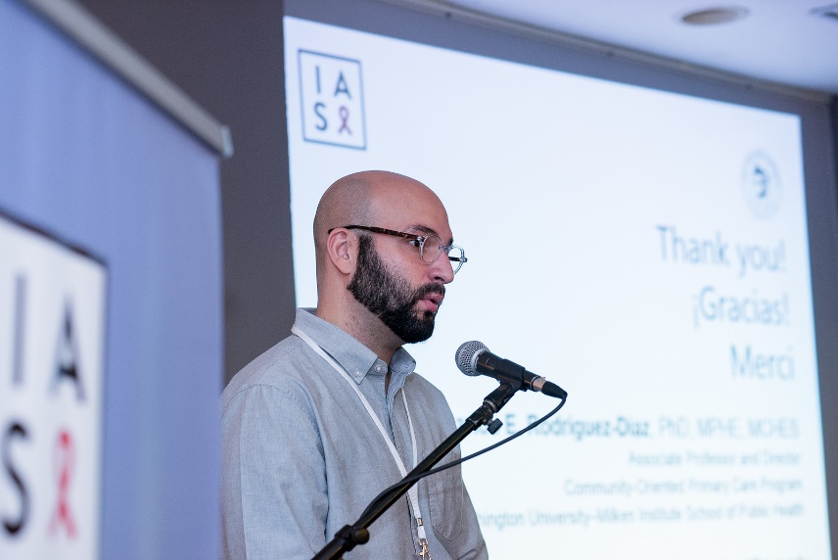
Dr. Carlos E. Rodríguez-Díaz (Adjunct Professor University of Puerto Rico Medical Sciences Campus) highlighted the hard context in Puerto Rico following the Maria hurricane as well as present political difficulties. In the context of the US HIV epidemics, Puerto Rico ranks 5th in HIV prevalence among adults and adolescents older than 13 with 564 cases per 100,000 inhabitants. Up to December 2017, 48,769 HIV cases and 28,663 deaths had been reported. PLHIV: 18,627. Children (0-12yo) diagnosed with HIV: 671. With a primary and secondary syphilis rate of 15 per 100,000 population Puerto Rico occupies first rank in the United States.
In a sample of HIV-positive MSM, less than 19% were aware of PEP or PrEP and 38% reported they won’t use PrEP because they cannot afford it. Less than 15% of primary healthcare providers have received training on LGBT health issues and 13.1% of LGBT have reported experiences of discrimination in healthcare settings.
Continuum of Care estimation (2013) showed that 18,386 people live with HIV and 10,441 are on ART. Approximately 46% of all PLHIV are virally suppressed.

Trinidad and Tobago: Dr. Ayanna Sebro summarized epidemiologic data on HIV for Trinidad and Tobago. PAHO estimated Adult HIV prevalence to approximately 1 % (.09-1.1) in 2014. HIV Prevalences in 2017: in General Population 1.2(%), in MSM Population 26.7(%) and in substance users 12.5(%). Females are tested more frequently and generally more than males.
Number of PLHIV: 11,000; Patients in care: 8111; Patients on treatment: 6,700; Viral load suppression: 4,972 (42.2% of PLHIV, 74% of patients on ART).
No PrEP programme is presently running.

Suriname:

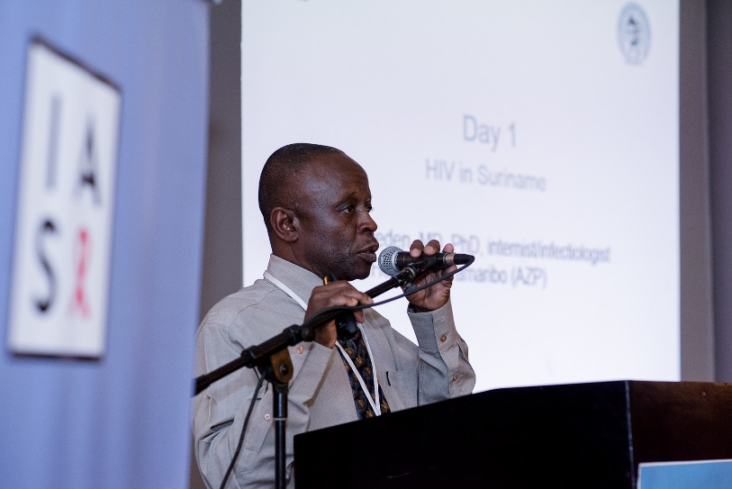
Dr Stephen Vreden, MD, PhD (Academic Hospital Paramaribo, AZP) presented epidemiologic data for Suriname. Number of PLHIV in 2017: 5,000. No gender disparity. Poor coverage of ART: 50%. Cascade continuum: 533 patients were linked to care at AZP, 349 retained, 322 on ART and 276 (86%) virally suppressed. Decrease of death between 2010 and 2017: 32%.

Among reasons of loss to follow-up (LTFU) when called include: high rates of reluctance to engage in care, poor self-acceptance, choice of alternative medicine, aversion of continuously taking meds, stigma and fear of being abandoned.

There are 150 annual number cases of TB: 82% pulmonary and 18% extra-pulmonary. HIV/TB co-infection: 28%. Most patients with co-infection presented with low CD4 at diagnosis and are younger. Mortality among HIV & TB co-infected patients: 27.9 % vs 10.9% in non-HIV infected TB.

Syphilis infections are increasing: up to 60% increase in VDRL screening at AZP between 2016 and 2018.

PrEP is presently available for conceiving discordant couples with ‘cold feet’ and for surgeons in emergency surgery of virally unsuppressed patients. It is not (yet) promoted or implemented for the general population, as they are awaiting decisions on funding.

Cuba:
Dr. Jorge Pérez Avila (Organisation: Instituto de Medicina Tropical “Pedro Kourí” reported data from 1986 to 2017: 28,659 cases of HIV were reported with 5,159 deaths. There were 23,500 PLHIV (82%) and 19,505 (83%) were on ART.
Characteristics of the Cuban epidemic: Low-level epidemic (prevalence 0.29%); mainly by sexual transmission (99%); mainly men (80.8%) and amongst them, MSM (89.9%). Good prevention of mother-to-child transmission of HIV (51 cases) and elimination of MTCT. Good control over blood donations and blood transfusions (only 21 cases reported).
93 children under 15 years of age (0.35% of all diagnosed cases) were diagnosed in the entire epidemic: 51 of them were transmitted through mother-to-child transmission. At the end of 2017, the elimination impact indicators are maintained.
TB/HIV Co-infection: 94 cases in 2017 (1/100,000 inhabitants).
Continuum of care Cascade: 80% of PLHIV diagnosed; 84% of eligible patients on ART; 73% of patients on ART virally suppressed. The priority goal for Cuba is to eliminate AIDS as a health issue by 2020.

Martinique:

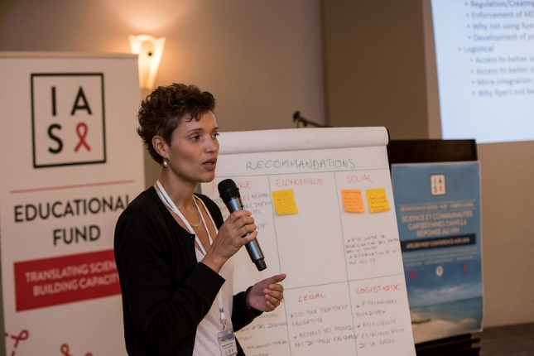
Dr. Sandrine Pierre-François (Service des Maladies Infectieuses et Tropicales, CHUM). In 2017, the number of patients living with HIV in French departments in America (DFA) were 494 in Saint Martin, 1,423 in Guadeloupe and 1,068 in Martinique (data was not provided for French Guyana).

The presentation focused on Martinique’s epidemics. Males: 62% (new patients: 70%) Transmission groups (%): Heterosexual 65.7(%); MSM 29.6(%) (raised to 46(%) in 2018); IVDU 1.2(%); Others 3.6(%). Co-infection: HBV 2.6% and HCV 4.3%.
Patients receiving ART: 95.4%, with 94.9% viral suppression rate (CV<50 cop/ml after 6 months treatment). Integrase inhibitor based ART became in 2018 the most commonly prescribed ARV regimen (92%).
There is a free access to HIV self-test in drugstores at a cost of €25 to €28, not reimbursed by insurance.

PAN Caribbean Partnership against HIV and AIDS (PANCAP):
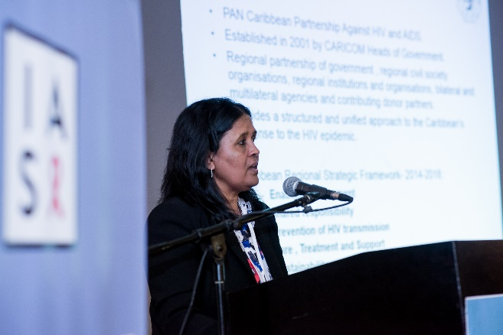
Dr. Shanti Singh-Anthony (Knowledge Coordinator) presented an overview on the status of PrEP, Retention Care and MDR TB in Caribbean Countries and Territories. PANCAP was established in 2001 by CARICOM. It aims to provide a structured and unified approach to the Caribbean’s response to the HIV epidemic.
In 2017, the number of PLHIV in the Caribbean was estimated at 310,000, with 15,000 having been recently infected. The number of deaths stood at 10,000. There was an 18% decline of new infections compared to 2010. There has been moderate progress in the prevention and treatment in the Caribbean: 57% of PLHIV (181,000 persons) are on ART and there is a 23% reduction in AIDS-related deaths. But patients still come in late for treatment: 23% of patients are diagnosed late with AIDS.

The treatment cascade for PLHIV in 2017 was as follows: 73% knew their status; 57% were on ART (men: 47%) and 40% were virally suppressed (70% of those on ARV). Median of viral suppression obtained in patients under ART is 69% among countries. The best results (close to 80%) were reported by the Dominican Republic and Barbados (94% for Martinique, not reported by PANCAP). Viral suppression of all PLHIV does not go over 48% when estimated (Bahamas, Barbados, Cuba, Suriname).

Stigma remains high: In Belize, 17% of PLHIV reported that they have avoided going to the local clinics in the past 12 months because of their HIV status. Up to 90% of PLHIV reported that health care providers at least once reported their status without their consent.
Only two countries reported that they provide PrEP in the Caribbean in the public sector and that they follow CDC/WHO guidelines.

The majority of TB cases in 2017 were reported in Hispaniola. Haiti reported 15,429 cases (122 MDR) and the Dominican Republic reported 4,093 (56 MDR). Total MDRTB cases reported in the Caribbean: 212 out of 21,232 (1%).

  - Panel discussion: PrEP implementation

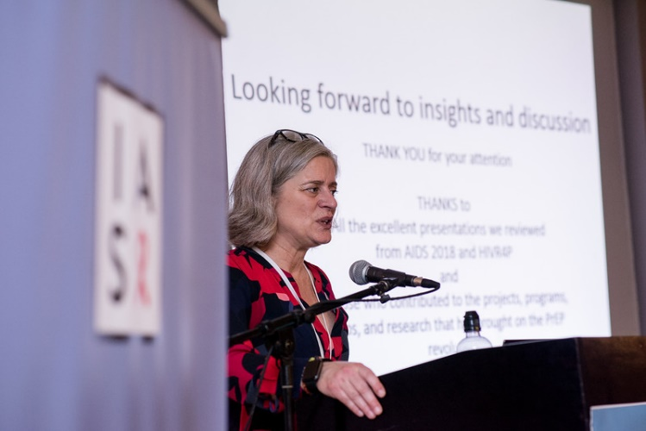
Dr K Rivet Amico, PhD, Associate Professor, University of Michigan, presented on “Positioning ourselves for effective PrEP implementation: Oral PrEP at AIDS 2018 and beyond”.

Dr Amico highlighted key emerging issues related to PrEP, and findings from AIDS 2018. She indicated that all started in 2010 with the Iprex study and that finally time of implementation had come. Despite US FDA approval in 2012 there was a failure to launch because of major concerns about efficacy, adherence, acceptability, and feasibility. There was lack of advertising, conservative guidelines, and considerable push back. But many trials have now demonstrated the efficacy of PrEP to up to 86%: Iprex, Proud, Partners PrEP, PrEPARE pilot and PrEPARE demo, Ipergay and others. Globally 300,000 people are currently using PrEP in about 68 countries, but 71% of users are in North America.
In the Caribbean public health services, PrEP has been implemented in the Bahamas and demonstration projects are ongoing with the support of international donors funding in several countries including the Dominican Republic, Haiti and Jamaica.

Key components to effective implementation of PrEP are access, uptake, adherence and continuity. Key populations that are targeted are those at highest risk: MSM, FSW, Young women, PWID. Youth continue to be under-represented. Adolescents accessing PrEP in the US represent 1.6% of all recipients (TUAC0305). Minority MSM, women, transgender people and other groups have limited access.

Reports at AIDS 2018 from Pintye and others suggest that low awareness on PrEP persists and limits uptake. Kinuthia et al (WEAE0402) offered PrEP to 9,171 uninfected women accessing ante- and postnatal care women from 16 sites in Kenya, 22% agreed (78% declined). Reasons included concerns about negative impact, wanting to consult partner, and perceived low HIV risk.

Dr Amico stressed that if PrEP delivery is part of a more comprehensive health and sexual health-focused service, continuity may be easier to expect than in the current system. Drops in PrEP “clients” were reported at AIDS 2018 across projects after 3, 6 and 9 months after PrEP initiation: Kenya [WEAE0403] and Senegal [TUAC020].

In order to meet the UNAIDS goal of linking 3 million people to PrEP by the year 2020, we must address each of these key issues related to PrEP implementation: What special considerations must be made for marginalized populations that may be particularly vulnerable to HIV infection? What will be the cost on already constrained health systems to introduce PrEP? Where can PrEP be provided to handle the volume of patients who may be eligible for PrEP once it is made available? Where will ideal implementation sites be? Can PrEP be provided in family planning facilities? And what training and monitoring and evaluation are necessary to evaluate potential sites for PrEP availability?

Key messages:
- The road has been long and filled with controversy;
- The controversy may largely be over in public health communities, but the work of dissemination and implementation has just begun;
- We still have a long way to go to get comprehensive sexual health services to people who could most benefit from them;
- There are many resources out there to use;
- Every effort matters;
- Above all, support and respect the dignity of those we serve.

Key recommendations from the participants’ group work on PrEP
Facilitating access to PrEP for key populations in the Caribbean requires a wide range of legal, economic, social, technological, and logistical considerations. The main recommendations presented through IAS group work are presented below:
- Enlist support from leadership at the highest levels. Investment in the implementation of PrEP by Ministries of Health in each Caribbean country are needed for successful rollout. Support is needed at the highest level;
- Ensure legal protections for key populations that are likely to already be marginalized and vulnerable. For minors, consider lowering the age restriction for when PrEP can be initiated;
- Integrate PrEP into existing healthcare systems and providers, such as primary care providers, to lessen additional cost and benefit from patients already presenting at key providers;
- Create a careful and comprehensive public messaging campaign to provide accurate education and perceptions of what and who PrEP is for. Campaigns must address existing stigma for key populations;
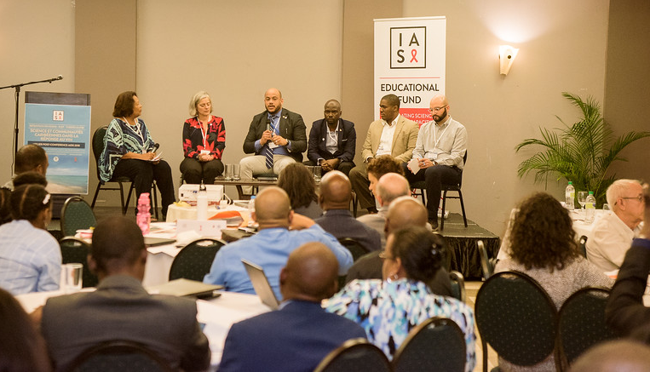
- Train healthcare providers at all levels to sensitize about PrEP, serving key populations, and get buy-in from key stakeholders. Providers must be ready to receive patients from key populations such as MSM or commercial sex workers, and provide care that is de-stigmatized;
- Make screening tests and medications available to assure follow-up and continuity of PrEP;
- Identify funding for PrEP from Ministries of health and from various donors to reduce cost on health systems.

  - Panel discussion: Retention in care
Prior to the panel discussion, Dr. James Wagude (National Aids and STI control program) presented the Kenya experience on retention in ART where HIV prevalence was 4.9 % in 2017 and 1.5 million of people are living with HIV. It is estimated that there are 1,493,382 PLHIV in Kenya, 73.3% are retained on ART and viral suppression is recorded for 58.3% of them.
Key factors affecting retention include distance to clinics, pill burden, stigma, HIV status denial, climate change and civil wars. Dr Wagude highlighted the fact that retention is worse in adolescents, and presented a research conducted in the Siaya County showing it was also worse in advanced PLHIV compared to PLHIV that were well at 12 months.
Development of Differentiated Service Delivery (DSD) policies and guidance was developed and introduced in Siyata County in 2017 as a demonstration project to improve retention before national implementation. This strategy put emphasis on services really tailored to patients’ profiles and categorize patients at enrolment as “well” or “advanced”.
Retention at 12 months was then found to be 77% for patients classified “well” and 83% for patients classified “advanced”.
Regarding adolescent “responsive” services, there is an operation triple zero (OTZ) encouraging to miss zero appointments, skip zero drug doses, and maintain a viral load of zero. Motto: “Heroes for Zeros and Zeros for Heroes, It takes a Hero to be a Zero and a Zero to be a Hero”. Results showed that more than 93% of adolescents kept clinic appointments and self-reported adherence increased from 88% to 96%.
For pregnant and post-natal women, some policies and implementation programmes include: home visits and community sensitization to encourage delivery at health facilities; increasing male involvement through self-testing and assisted partner notification and disclosure; peer support through mentor mothers who provide education and psychosocial support; integrated mother-baby pair clinics in antenatal clinic and tracking and tracing standard operating procedures for defaulter tracing. Retained rate at 12 months was 76%.

Integrating HIV in prenatal centers increased retention from 64% to 73%.
For pediatric patients, programmes include: establishing special clinic days; hunger score and vulnerability assessment; initiated caregiver literacy sessions and social support. In the Turkana County, adding a social support and feeding showed that percentage of pediatrics keeping appointment went from 66 to 84%.

Dr Wagude concluded by pointing out that that retention strategies require meaningful engagement with PLHIV and multi-stakeholder participation and need to be adapted and cost-effective.
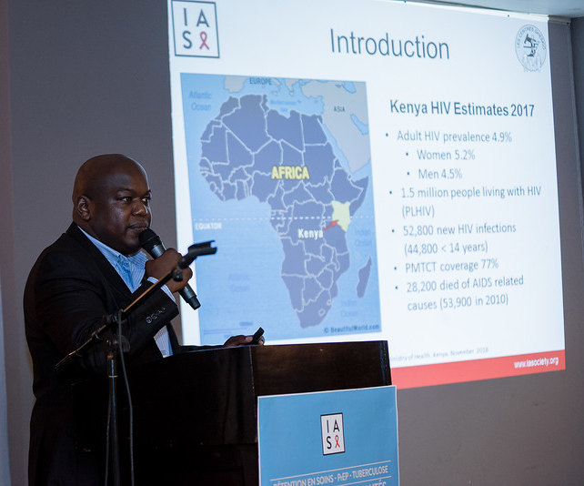

The panel discussion followed with participants from several Caribbean countries who commented on:

Major steps to boost Caribbean countries so they can meet the retention goal are: rapid testing services, early infant diagnosis, community testing, fight against discrimination, drug access to migrants, women empowerment, psychosocial services and government involvement.

Strategies to meet the 90-90-90: Care reinforcement, community involvement with polyvalent community health workers, changing the whole system of care, multi-month scripting and patient linkage and retention program.

Specificities of small Caribbean islands to reach the 90-90-90 (and recently 95-95-95) goal: even though it is easy to reach a small number of people, managing the program and allocating more time for individual interventions, privacy and confidentiality, self-stigma, discrimination and drugs stock-out remains to be challenging.

Following the panel session, participants formed working groups to discuss and bring key recommendations to the table for a call to action based on the presentation and previous discussions.

Key recommendations from the participants’ group work on retention in care:
- Build research approaches at country and regional levels to understand the real factors associated with loss to follow-up: necessity to learn from the patients themselves;
- Improve the quality of care and community awareness through behavioral change and social networking;
- Reach people in hard-to-access area by drone-delivery drug;
- Improve patients’ health literacy and allow them to understand the economic significance of their care by inviting them to financially contribute even at a very minimal level;
- Prioritize task shifting between doctors, nurses and social workers;
- Decrease stigma and discrimination at the general population level, improve welcoming and quality of care at the institutional level;
- Integrate a model of care for migrants and key and vulnerable populations;
- Allow Electronic Medical Records connection so patients can have access to ART wherever they are in a country.

  - Panel discussion: Tuberculosis and MDR-TB
Prior to the panel discussion, Dr. Jean William Pape (Professor, Weill Cornell Medical College, New York, NY and Director, Les Centres GHESKIO, Haiti) presented the current global TB burden as well as ongoing strategies to increase TB case notification, decrease transmission of TB and improve TB treatment outcomes in the context of the HIV epidemic. He discussed diagnostic and programmatic interventions to address challenges such as increasing rates of MDR-TB, long duration of treatment and the dual burden of HIV/TB co-infection.

Dr Pape highlighted the current situation of TB in the Americas region, mostly concentrated in Haiti and the Dominican Republic. Overall, 3% of the global TB burden is diagnosed in the Americas. Although TB mortality has significantly decreased over the past 15 years, it remains high (16% fatality rate for all forms of TB cases, and 40% for MDR-TB). However three key critical HIV/TB benchmarks demonstrate areas for improvement to end TB: only 60% of TB patients are presently tested for HIV; only 36% of HIV-positive patients receive IPT; and only 41% of HIV-positive TB patients are receiving ART.

Dr. Pape described numerous interventions aimed to curb the TB epidemic in resource-limited settings, emphasizing the need for strategies that address the deadly association between both diseases, TB and HIV simultaneously. He discussed the high diagnostic yields of an integrated TB/HIV testing strategy in Voluntary Counseling Testing centers and active case finding for TB at the household level using chronic cough, as well as the impact of improved TB diagnostics, such as Xpert MTB/RIF in increasing TB diagnosis among HIV-positive patients. Among 5,800 patients screened for cough in a Haitian slum 20% were diagnosed with TB.

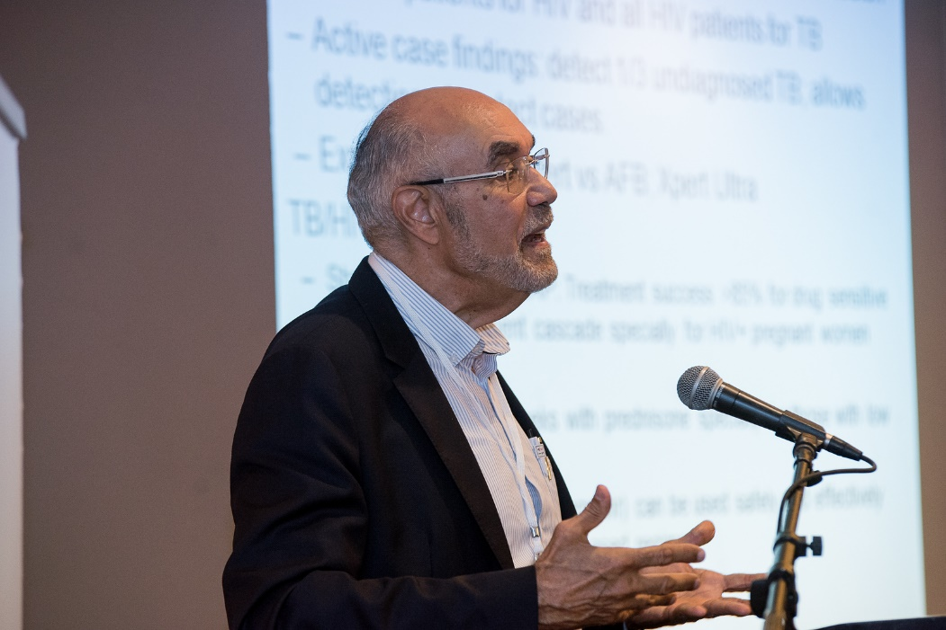
Dr. Pape reported that if we already knew that PLHIV had a 4-20 times higher risk to get TB, a presentation at AIDS 2018 Amsterdam congress showed that the risk of re-infection is even higher after successful treatment (Hermans et al SA).

As many remain concerned about IRIS when initiating TB treatment, Dr. Pape summarized all the studies that have defined the best timing to start ARV (Collins et al, Havlir et al, Camelia study and others). He then presented data from a recent paper that established the preventive role of prednisone: IRIS occurred much more frequently at CD4 <50/cells/µL, but less in patients receiving prednisone with no increased risk of severe infections (Meintjes G et al, 2018).

A presentation at AIDS 2018 in Amsterdam showed the bad outcomes for HIV/TB co-infected pregnant women, highlighting that HIV MTCT was 11% in comparison to 2% for infants, while infants’ TB infection was 7% in comparison to 1% (Deschamps et al).

Data from Brazil (Pacheco et al), and some very recent and unpublished data from South America and Haiti indicates that there is an increased risk of mortality from non-TB-related causes among HIV+ patients that have been previously successfully treated for TB.

A new concern also emerged from a presentation at AIDS 2018 about excess mortality in TB led by discordance in susceptibility tests (Kathrin Zürcher et al).

Prevalence of new MDR-TB cases in 2008 was 2.9% in Haiti. Between 2008 and 2015, mortality rate decreased from 50% to 8.9% and the success rate was over 78%.

A new highly effective and inexpensive short course (39 weeks) MDR-TB treatment is being implemented in Haiti by PLNT, PIH and GHESKIO. It associates with bedaquiline, levofloxacine, linezolid, clofazimine and pyrazinamide.

Dr. Pape closed the presentation with success stories of IPT among HIV-positive patients to prevent TB transmission and also of GHESKIO’s MDR-TB hybrid treatment plan of intensive and ambulatory care. He made a call for early TB treatment among HIV-positive patients, sharing evidence of dolutegravir as a safe alternative to efavirenz-based regimens.

The panel discussion was built around the following topics: scaling up of TB diagnostics in Caribbean countries, integrating TB testing at the time of HIV testing and the limited accessibility to novel MDR-TB regimens in the region.

The primary challenge for many Caribbean countries to end TB in the face of the HIV epidemic is to have access to TB diagnostic tools; strategies that overcome supply chain shortage and logistical challenges, such as sputum transport at a national level.
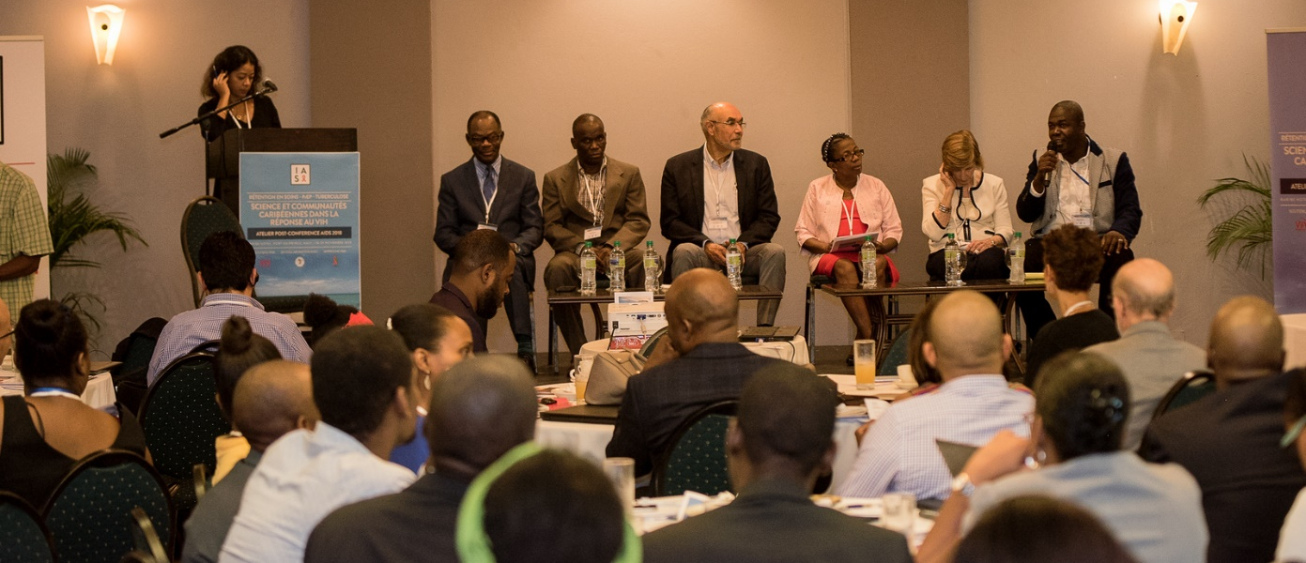

Key recommendations from the participants’ group work on HIV and TB:
- Prioritize interventions that allow for early diagnosis, treatment and prevention of both HIV and TB;
- Allocate political resources more efficiently to engage and align all sectors of society in preventing TB transmission;
- Create policies around TB infection control, especially in countries with high migration and mobility;
- Garner private and public funding to nationally implement key strategies such as active TB case finding at the community level as part of standard care;
- Increase screening of case contacts through social workers sent at home;
- Invest in dissemination of X-ray devices to improve TB diagnosis: It is unacceptable to not have these tools in developing countries where they are most needed;
- Invest more in Xpert machines as a necessary diagnostic tool;
- Develop prison TB screening policies;
- Promote group activism at both the community and political levels to champion the cause to end TB among high-risk populations such as prisoners, immigrants, adolescents and PLHIV;
- Decrease stigma and promote social supports groups: mentor, peers for DOT;
- Integrate TB guidelines in medical and nursing school curriculum;
- Conduct research to identify drivers of TB transmission and to develop better resources for screening tools;
- Integrate TB and HIV national programs to adapt national policies to address both diseases.

Conclusion
The two-day post-conference AIDS 2018 workshop was held to discuss scientific research results on specific topics which were presented in Amsterdam in July 2018. Those topics had to be reviewed for policy and programme improvements in the Caribbean region. The key themes selected for the meeting were: retention in care, implementation of PrEP and improvement of Tuberculosis care. This selection of themes was done to better answer priority expectations from managers and health care workers as well as specific expectations of most vulnerable populations or groups exposed to STI and HIV infections in the Caribbean region.
Attendance to the workshop was high despite travel difficulties in the Caribbean region and political turmoil in Port-au-Prince days before the meeting. There was quite a good representation of countries and territories. Key and vulnerable populations representatives were present (MSM, CSW, Youth) though more of them were expected to participate.
On the first day, Dr Soto-Ramirez presented a selection of data from the Amsterdam AIDS 2018 conference and Dr Rivet Amico focused on PrEP implementation updates. Participants really appreciated the conference’s summaries of important presentations because few people had had the opportunity to attend the conference in Europe in July 2018.
On the second day, participants of the workshop attended two keynote presentations on retention in care (Dr Wagude) and Tuberculosis and MDR-TB (Dr. Pape). Following the panel discussions, participants were separated into three groups to prepare recommendations on each theme of the meeting.

On both days, specific challenges in each Caribbean country or territory were discussed. Although the region has been slow at implementing PrEP, new data presented are encouraging to move forward. TB is a concern in all places, but clearly there is a concentration of cases in Hispaniola. New diagnostic tools and treatment regimens are being implemented and there is hope to get better patient outcomes, including better control of the TB epidemic.
Summary of challenges in HIV treatment and epidemic control in the Caribbean:
- Moderate progress has been made in prevention and treatment in the Caribbean;
- Significant gaps remain to reach the 90-90-90 or the 95-95-95 targets;
- Stigma and discrimination continue to be a major obstacle to access to services;
- Supply chain issues continue to challenge some territories in the region - ARVs, reagents for experts machines and supplies;
- There is an increasing demand for PrEP -- particularly from key populations – but implementation has been somewhat slow;
- High uptake of HIV testing among TB patients links to high TB/HIV co-morbidity in the region. TB continues to be a leading cause of death in HIV patients in territories with significant TB/HIV epidemics.
Summary of emergent issues and challenges in retention in care:
- Retention in care depends on many universal and specific factors;
- Strategies to meet the 95-95-95 target include: care reinforcement, community involvement with polyvalent community health workers, making changes to the health care system, multi-month scripting and patient linkage and retention program;
- Build research approaches at country and regional levels to understand real factors associated with LTFU: There is a necessity to learn from the patients themselves;
- Improve welcoming, quality of care and community awareness by behavioral changing and social networking;
- Reach people in hard-to-access areas by drone drug delivery;
- Time for patients to wait in clinics and laboratory waiting rooms must be shortened;
- Long distances between homes and health care centers must be reduced wherever possible;
- Single co-formulated tablet, such as TLD, decrease patient constraints;
- Gender-based violence, including for trans-women, gender inequality, disparities in care, self-discrimination and denial are challenging factors;
- Bridging the knowledge-skills gap;
- Utilization of the viral load tool as a clinical management tool;
- Policies and availability of drugs are not enough to retain patients.

Summary of emerging issues and challenges with PrEP:
- Risk compensation and higher STI rates;
- Elevated risk of new HVC infections among MSM;
- Vulnerabilities of marginalized populations (overcome stigma and inequality toward MSM, TG women, homeless people, PWID, adolescents and younger age (25-29), migrants and indigenous populations).
- Prevention programmes: it is important to ensure comprehensive sexuality education and to address psychosocial conditions;
- Risk perception may be low. PrEP should be offered through friendly health systems;
- Determine whether there are certain patients to whom we should recommend on-demand PrEP;
- PrEP recommendations for women and for adolescents;
- Determine what the ideal place is to offer PrEP;
- Raise awareness on the cost required for the health system;
- We are still short of the UNAIDS goals of linking 3 million persons to PrEP by 2020;
- Introduce and scale up PrEP pilots among key populations in the Caribbean;
- Institutional buy-in— determine how we can get governments, CBOs, other CSOs to become leaders in the planning and implementation of PrEP;
- Financial barriers – assess what is the cost to obtain readily available PrEP, and on the health system to integrate PrEP into already constrained HIV care. Can we integrate with routine primary care?
- Public messaging – There is a key opportunity to shape perceptions of PrEP, not only for MSM and commercial sex workers, but for all patients at risk. It should be determined how compensatory behaviors and resistance affect our public message and subsequent acceptability/uptake;
- Health care provider (HCP) training – success of PrEP is dependent on HCPs providing stigma-free care for key populations. How do we first overcome discrimination in HCPs before providing PrEP?
Summary of emergent issues and challenges with TB:
- Outcomes of patients with MDRTB have been greatly improved in Haiti: the success rate was over 78% in one facility;
- Treatment of MDR/RR-TB include new drugs, combinations and treatment duration;
- Cost and availability of tests and drugs remain a concern;
- Adequate treatment needs DST but recent data about discordance between sensibility tests have emerged, impacting negative outcomes;
- DTG at double dose (bid) is virologically non-inferior to EFV during TB-treatment;
- Preventive therapy is useful, but there is still limited coverage, even in high burden countries;
- TB remains a top ten cause of mortality among people living with HIV in the Caribbean;
- Increased testing among people living with HIV; however, co-infection rates remain relatively high in concentrated areas of the region;
- TB and MDR-TB treatment completion rates are poor;
- Consider integrated HIV/TB strategies such as community-based active case finding of TB, TB screening and testing at time of HIV testing, and intensified case finding using more sensitive TB diagnostic tools such as Chest X-Ray, Xpert MTB/RIF or Xpert Ultra testing;
- Use more sensitive TB diagnostic tools such as Chest X-Ray, Xpert MTB/RIF or Ultra testing.
The objectives of the AIDS 2018 post-conference workshop were achieved. The workshop provided a good opportunity to share epidemiological, clinical and managerial experiences from countries and territories with diverse political status, languages and rank in development. Some territories are used to share data only with countries that they are politically tied to such as Martinique, Puerto-Rico, and the Dutch islands which report respectively to France, the US or the Netherlands. Others countries report only to WHO. Meetings unlinking political ties to exchange data and experiences as well as providing opportunities to network are uncommon but necessary in order for HIV professionals all over the region to better understand innovations and provide good follow up services to populations migrating between territories in the region.
The next IAS Conference on HIV Science (IAS 2019) will take place in Mexico City and many participants of the workshop held in Haiti hope to be able to attend.

Appendix 1 - Programme

AIDS 2018 Post-Conference Workshop
RETENTION IN CARE – PrEP – TUBERCULOSIS
SCIENCE AND COMMUNITY IN THE HIV RESPONSE IN THE CARIBBEAN

Date: 28-29 November 2018

Location: Hotel Karibe, Port-au-Prince, Haiti

Objectives and expected outcomes:
The objectives of the IAS Educational Fund workshop were to present key scientific and policy content from the AIDS 2018 Conference, and for participants to discuss how to effectively translate these into local policy and practice in the Haitian and Caribbean contexts. A particular focus was placed on three themes pertinent for the region: Retention on ART, PrEP implementation and co-morbidities (TB/MDR-TB).

The expected outcomes of the meeting was to generate key recommendations from participants, on the translation of the latest science on Retention in Care, PrEP and Tuberculosis in the Caribbean region.

IAS Governing Council representative present onsite:
- Professor Luis Soto-Ramirez, Head, Molecular Virology Unit, Department of Infectious Diseases, Salvador Zubiran National Institute of Medical Science and Nutrition, National Institute of Health, Mexico City, Mexico

Panel discussions moderators:
- Dr Jessy Devieux, Robert Stempel School of Public Health, Florida International University, USA
- Dr Bernard Liautaud, Les Centres GHESKIO, Haiti
- Dr Elena Cyrus Cameron, University of West Indies, USA

Participants: 81 participants including clinicians, healthcare workers, policy makers, researcher, civil society and representatives of key populations including 15 representatives from the Caribbean region (Jamaica, Trinidad and Tobago, Antigua and Barbuda, Dominican Republic, Barbados, Martinique, Saint Vincent and the Grenadines, Suriname, Puerto Rico, Cuba).

Chairs 28 November 2019:
- Dr Luis Soto-Ramirez, IAS Governing Council Representative, Mexico
- Dr Jean William Pape, Les Centres GHESKIO, Haiti

Chairs 29 November 2019:
- Dr Monica Thormann, Dominican Society of Infectious Diseases, Dominican Republic
- Marie-Marcelle Deschamps, Les Centres GHESKIO, Haiti
Programme - Wednesday 28 November
08:00-09:00 Registration & Networking

09:00-09:15 Opening
      - Dr Luis Soto-Ramirez, IAS Governing Council Representative, Mexico
      - Dr Jean William Pape, Les Centres GHESKIO, Haiti

Words of welcome
      - Joelle Daes, Ministry of Health, Haiti

09:15-09:45 Participants' Introductions

09:45-10:45 Key messages from AIDS
      - Dr Luis Soto-Ramirez, IAS Governing Council Representative, Mexico

10:45-11:00 Coffee Break

11:00-12:00 HIV in the Caribbean Region in:

- Haiti: Dr Francois Kesner, Programme National de Lutte contre le Sida
- Jamaica: Dr Geoffrey Barrow, Ministry of Health
- Barbados: Dr Nastassia Rambarran, EQUALS Barbados
- Dominican Republic: Dr Ellen Koenig Dominican Institute for Virological Studies
- Antigua and Barbuda: Dr Eleanor Frederick Antigua and Barbuda HIV/AIDS Network (ABHAN)
- Puerto Rico: Dr. Rodriguez-Diaz, University of Puerto Rico

12:00-13:00 Lunch

13:00-14:00 HIV in the Caribbean Region in – continued

- Trinidad and Tobago: Dr Ayanna Sebro, Technical Director of National AIDS Coordinating Committee Secretariat
- Suriname: Dr Stephen Vreden, Centre of Excellence infectious diseases
- Cuba: Dr Perez-Avila, Minsap IPK
- French Antilles: Dr Sandrine Pierre François, CHU Martinique (representing Guadeloupe, Martinique, Guyane, St Martin)
- Caribbean region: Dr Shanti Singh-Anthony, PANCAP (from Guyana but representing the region)

14:00-14:15 Coffee Break

14:15-16:45 Panel Discussion: PrEP implementation

Keynote speaker: Positioning ourselves for effective PrEP implementation: Oral PrEP at AIDS 2018 and beyond, Dr K Rivet Amico University of Michigan, USA

Panel moderator: Dr Jessy Devieux, Robert Stempel School of Public Health, Florida International University, USA
Panellists:
- Dr K Rivet Amico University of Michigan, USA
- Dr Paulino Ramirez, Institute of Tropical Medicine and Global Health – UNIBE, Dominican Republic
- Dr Max Bond Saint Val, Key population representative, LINKAGES, Haiti
- Carlos Rodriguez Diaz, University of Puerto Rico (KPs perspective), Puerto Rico

16:45-17:00 Closing Remarks & Evaluation

Programme - Thursday 29 November
08:30-09:00 Networking coffee
09:00-09:15 Opening comments and welcome / Overview of the day
- HIV in the Dominican Republic: Dr Monica Thormann, Dominican Society of Infectious Diseases, Dominican Republic
09:15-11:15 Panel discussion: Retention in ART

Keynote speaker: Dr James Allan Angawa Wagude, Ministry of Health, Kenya

Panel moderator: Dr Bernard Liautaud, Les Centres GHESKIO, Haiti
Panellists:
- Dr James Allan Angawa Wagude, Ministry of Health, Kenya
- Dr. Gregory Boyce, Deputy Director of the Medical Research Foundation of Trinidad and Tobago, Trinidad and Tobago
- Dr Kathy-Ann Robinson, University of the West Indies, Jamaica
- Dr Ermane Robin, Ministry of Health, Haiti
- Mr. Winfield Tannis-Abbott, CRN+ , St Vincent and Grenadines
- Dr Mathon, Haiti, Les Centres GHESKIO
11:15-11:30 Break

11:30-13:00 Panel Discussion: TB/MDR-TB

Keynote speaker: Dr Jean William Pape, Les Centres GHESKIO, Haiti

Panel moderator: Dr Elena Cyrus Cameron, University of West Indies
Panellists:
- Dr Milot Richard, Programme National de Lutte contre la Tuberculose, Haiti
- Dr Philomène Durosier, Nos Petits Frères et Soeurs, Hôpital St Damien, Haiti
- Dr Wisny Docteur, Partners in Health, Haiti
- Dr Willy Morose, Ministry of Health, Haiti

13:00-14:00 Lunch

14:00-14:15 Rapporteur(s) Summary: Dr Bernard Liautaud, Les Centres GHESKIO, Haiti

14:15-16:45 Group work: Call to action for translating the latest science on Retention in Care, PrEP and Tuberculosis in the Carribean region with questions and answers
- Lead facilitator: Vanessa Rouzier, Les Centres GHESKIO, Haiti
16:45-17:00 Closing Remarks

